|  |  |
| --- | --- |
| Date | 8th October 2022 |
| Team ID | PNT2022TMID31860 |
| Project Name | Real-Time River Water Quality  Monitoring and Control System |

Step 1:

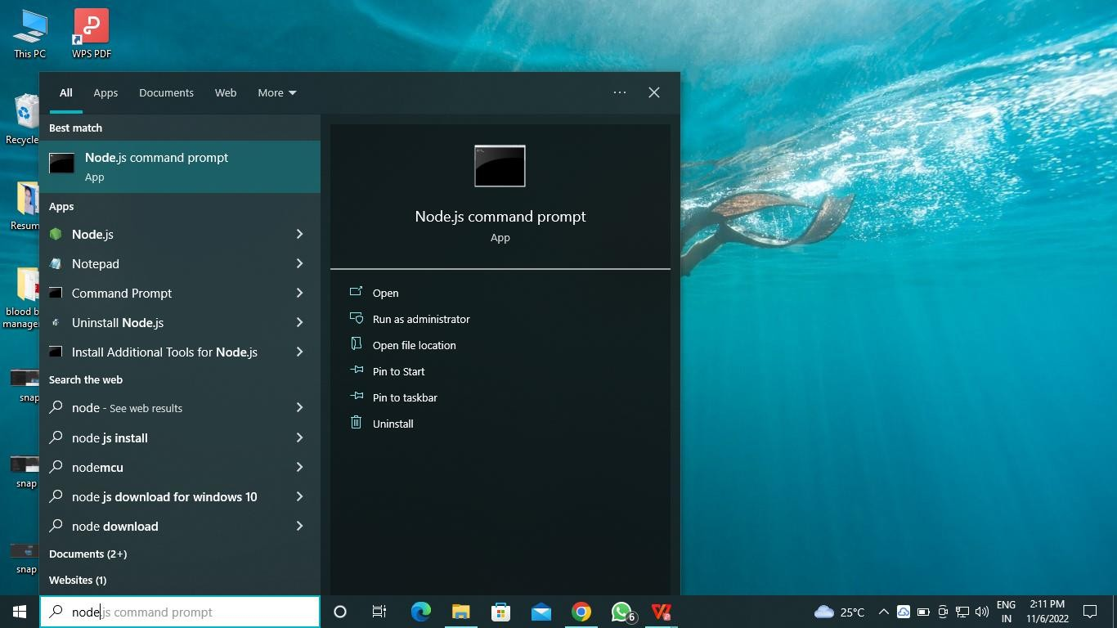

Step 2:

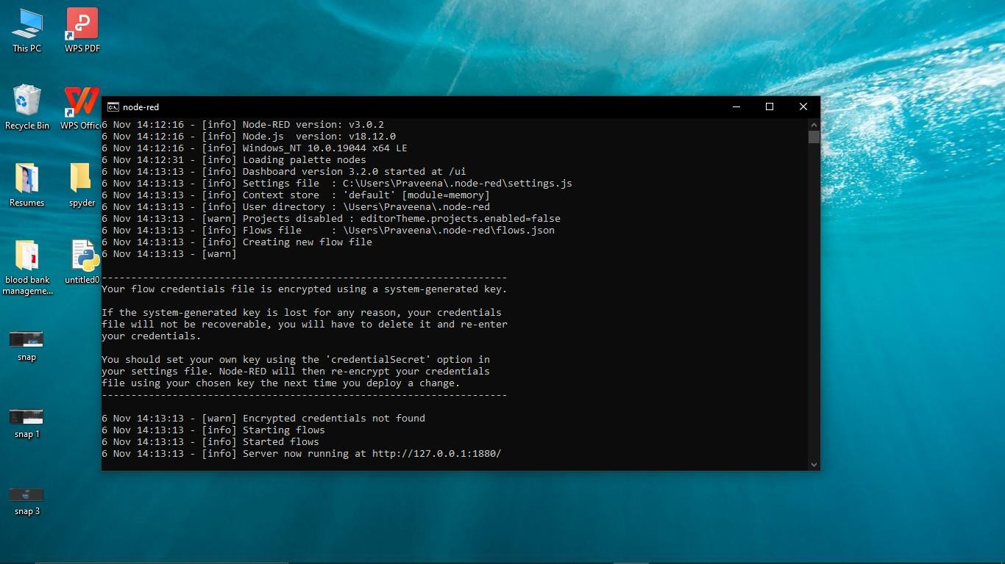

Step 3:

